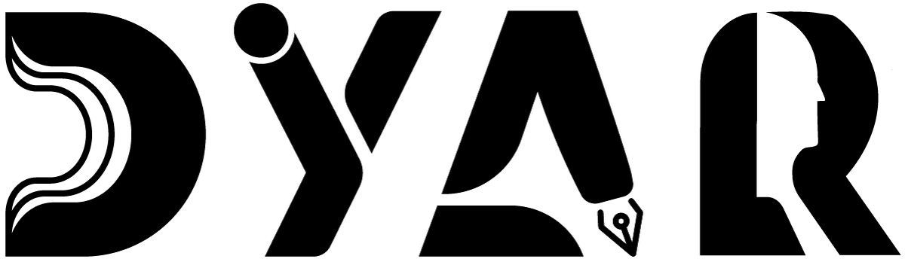
An NDIS Service Provider
RESOURCES HUB · TRAINING
Training Materials
Resources to understand your supports, your rights, your NDIS plan, and practical skills — multi-language available.
Aligned to NDIS Practice Standards · NDIS Code of Conduct · NDIS Act 2013

Version 2 · 12 May 2026
DYAR Pty Ltd
NDIS Provider No. pending (Application 4-LRFP0J8) · ABN 68 695 255 504
Unit 1, 136 Main Street, Osborne Park WA 6017 · PO Box 8052, East Subiaco WA 6008
0470 540 306 · hello@dyar.com.au · Whadjuk Country

Training Materials
Resources to help you understand your supports + your rights
Understanding DYAR's services
Short videos + Easy Read explainers for each DYAR service line:
• Core Support (Personal Care + Community Access + Transport)
• Specialist Support Coordination
• Psychosocial Recovery Coach
• Specialist Behaviour Support
• Occupational Therapy + Counselling + Psychology
• Specialist Disability Accommodation
• Consumables delivery
Understanding the NDIS
• What the NDIS is + how it works
• Your NDIS plan + budget + line items
• Plan-managed vs Self-managed vs NDIA-managed
• Your rights as an NDIS participant
Understanding your rights
• 12 CM1 Person-Centred Support Principles — Easy Read
• NDIS Code of Conduct
• Restrictive Practice — what you should expect
• Reportable Incidents — what gets reported and why
• Privacy + how DYAR uses your information
Practical skills
• How to use Splose participant portal (videos)
• How to ask for help / give feedback
• How to give consent (or withdraw it)
• How to make a complaint
• How to ask for an advocate
• How to read your NDIS plan
Specialist training (where relevant)
• Living with a Behaviour Support Plan — what you should expect
• Living in SDA / SIL
• Recovery-Oriented Practice for psychosocial disability
• Transitioning from ECEI to Thriving Kids (under 8)
Multi-language
Training materials available in:
• English (standard + Easy Read)
• Persian / Farsi (Mehdi — NAATI interpreter)
• Auslan (interpreter on request — free)
• Mandarin, Arabic, Hindi, Vietnamese (NAATI interpreter on request)
• Other languages on request
Request any topic in your preferred format. We will provide it.
___________________________________________
DYAR Pty Ltd · ABN 68 695 255 504 · Unit 1, 136 Main Street, Osborne Park WA 6017 · 0470 540 306 · hello@dyar.com.au · dyar.com.au · Whadjuk Country · V1 19 May 2026

